INTERFERENCE MAPPING

USE OF RENEWABLE ENERGY FOR RURAL

ELECTRIFICATION

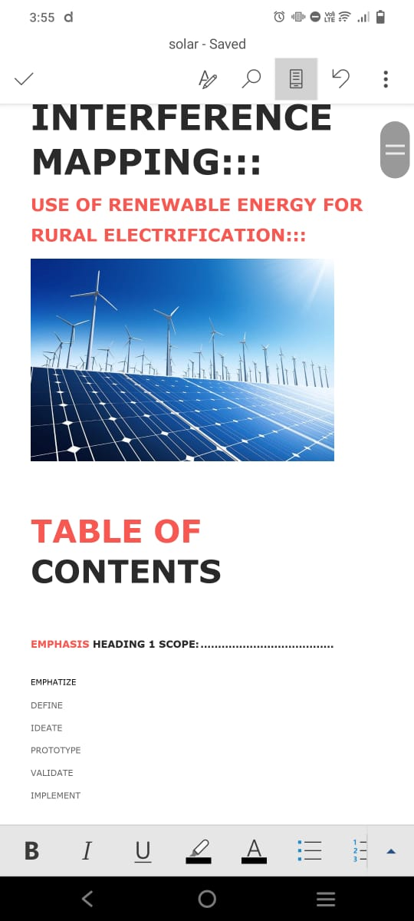

TABLE OF CONTENTS

EMPHASIS HEADING:

1.SCOPE

2.EMPHATIZE

3.DEFINE

4.IDEATE

5.PROTOTYPE

6.VALIDATE

7.IMPLEMENT

SCOPE: - TO IMPLEMENT A RENEWABLE ENERGY FOR RURAL ELECTRIFICATION.

EMPATHIZE: - THE TATA COMPANY VISITS A RURAL VILLAGE AND KNOW THAT THEY ARE FACING ELECTRICITY PROBLEMS IN VILLAGE FROM MANY YEARS, SO THEY DECIDED TO BUILD A RENEWABLE SOURCE OF ENERGY TO THE VILLAGERS, WHICH WILL HELP THEM A LOT, AND VILLAGERS ALSO ACCEPTED IT.

DEFINE: - THEN TATA AND THEIR COMPANY STAFF FINALLY DEFINED THAT THEY BUILD A RENEWABLE PLANT IN THE VILLAGE.

SO THAT VILLAGE WILL NOT FACE ELECTRIC PROBLEMS.

IDEATE: - THE PLAN OF THE TATA GROUP IS THAT TO BUILD SOLAR AND WIND POWERPLANTS IN THE VILLAGE.

THEY PLANNED TO BUILD SOLAR POWER PLANT IN 10 ACRES AT OUTSIDE OF THE VILLAGE.

AND WIND TURBINE NEAR THE FOREST OF THE VILLAGE.

PROTOTYPE: - THE GROUP FINALLY DRAWED A BLUE PRINT AND TRIED ALL POSSIBLE OUTCOME TO SOLVE IT

AND PROTOTYPE FINALLY SUCCEEDED.

VALIDATE: - THEY FINALLY VALIDATE ALL PROBLEMS IN IT AND THEY VALIDATED THE TOTAL PROJECT AND THEY FINALLY IMPLEMENT IT.

REFERENCE ARTILE

TITLE: -Renewable Energy for Rural Electrification in India: Challenges and Opportunities"

SOURCE: -International Journal of Renewable Energy Research (IJRER)

AUTHORS: -Anil Kumar, Nisha Chauhan

PUBLISHED: - 2022

INFERENCE REPORT

1. Overview of the Article:

The article examines the potential of renewable energy sources, such as solar, wind, and biomass, for rural electrification in India. It highlights how the use of decentralized renewable energy systems can address energy shortages and improve the quality of life in rural areas. The article also discusses the social, economic, and environmental benefits of integrating renewable energy into rural power infrastructure.

2. Key Findings:

Solar Energy as a Key Driver: Solar energy, with its abundance and scalability, is considered the most promising renewable energy source for rural electrification. Small solar PV systems can be deployed in remote areas, ensuring access to electricity where the conventional grid cannot reach.

Economic Viability: The decreasing cost of renewable technologies, particularly solar photovoltaic (PV) panels, has made rural electrification more economically feasible. Solar home systems, solar pumps, and mini-grids are providing low-cost energy alternatives for rural communities.

Challenges Identified:

Financial Barriers: Despite decreasing costs, the initial capital required for renewable energy systems can still be a burden for rural households.

Technical Challenges: Limited technical expertise in rural areas can hinder the maintenance and operation of renewable energy systems.

Policy and Infrastructure Gaps: Lack of consistent government policies and weak grid infrastructure pose challenges for the large-scale implementation of renewable energy solutions in rural regions.

3.Opportunities for Growth:

The article outlines several opportunities to boost renewable energy adoption in rural electrification:

Government Initiatives: Expanding government programs such as the Pradhan Mantri Sahaj Bijli Har Ghar Yojana (Saubhagya) and schemes like the KUSUM project, which supports solar pumps for farmers.

Public-Private Partnerships: Promoting collaboration between the government and private companies to finance, install, and maintain renewable energy systems.

Capacity Building: Training local communities in the operation and maintenance of renewable energy infrastructure to ensure sustainability and local job creation.

4. Social and Environmental Impact:

The article emphasizes that rural electrification through renewable energy can significantly reduce reliance on fossil fuels, contributing to lower carbon emissions. It can also enhance the social fabric by providing electricity for schools, health centers, and community centers, thus improving education, healthcare, and overall well-being in rural areas.

5.Conclusion:

The article concludes that renewable energy holds immense potential to transform rural electrification in India. However, overcoming financial, technical, and policy-related challenges is essential to ensure long-term success. The authors advocate for stronger government policies, increased investment, and enhanced local capacity-building initiatives.

This inference report highlights the main findings and recommendations of the article, underscoring the role renewable energy can play in addressing rural electrification challenges.